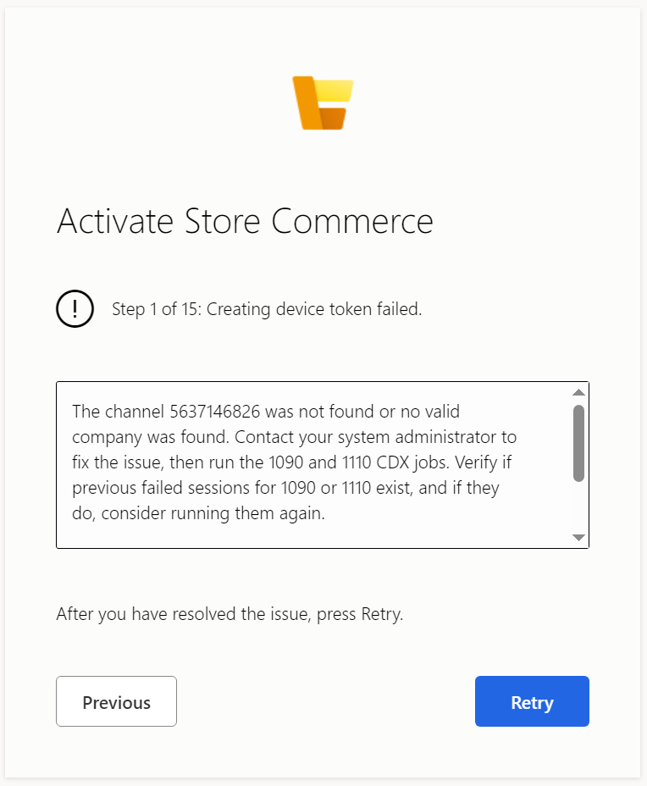

Solution:

Open the RetailChannelDatabase

Run the below queries and check whether data is available or not

**Query 1:**

SELECT   
  rct.RECID AS CHANNELID,  
  rct.INVENTLOCATIONDATAAREAID AS COMPANY,  
  lpa.LOCATION,  
  lpa.RECID AS LOCATIONRECID,  
  TABLEMISSING = CASE WHEN lacr.COUNTRYREGIONID IS NULL OR l.PRIMARYFORLEGALENTITY IS NULL THEN 1 ELSE 0 END,  
  lpa.ISPRIVATE,  
  EXPIRED = CASE WHEN GETUTCDATE() BETWEEN lpa.VALIDFROM AND lpa.VALIDTO THEN 0 ELSE 1 END,  
  lpa.VALIDFROM, lpa.VALIDTO,  
  GETUTCDATE() AS CURRENTDATETIME,  
  HASLEDGER = CASE WHEN l.PRIMARYFORLEGALENTITY IS NULL THEN 0 ELSE 1 END,  
  HASDIRPARTYTABLE = CASE WHEN dpt.RECID IS NULL THEN 0 ELSE 1 END,  
  HASDIRPARTYLOCATION = CASE WHEN drl.PARTY IS NOT NULL THEN 1 ELSE 0 END,  
  HASLOGISTICSPOSTALADDRESS = CASE WHEN lpa.LOCATION IS NOT NULL THEN 1 ELSE 0 END,  
  HASLOGISTICSADDRESSCOUNTRYREGION = CASE WHEN lacr.COUNTRYREGIONID IS NOT NULL THEN 1 ELSE 0 ENDFROM [ax].RETAILCHANNELTABLE rct  
  LEFT JOIN [ax].COMPANYINFO ci ON ci.DATAAREA = rct.INVENTLOCATIONDATAAREAID  
  LEFT JOIN [ax].LEDGER l ON l.PRIMARYFORLEGALENTITY = ci.RECID  
  LEFT JOIN [ax].DIRPARTYLOCATION drl ON drl.PARTY = ci.RECID AND drl.ISPOSTALADDRESS = 1 AND drl.ISPRIMARY = 1LEFT JOIN [ax].LOGISTICSPOSTALADDRESS lpa ON lpa.LOCATION = drl.LOCATION  
  LEFT JOIN [ax].LOGISTICSADDRESSCOUNTRYREGION lacr ON lacr.COUNTRYREGIONID = lpa.COUNTRYREGIONID  
  LEFT JOIN [ax].DIRPARTYTABLE dpt on dpt.RECID = ci.RECIDWHERE rct.RECID = <channelid>ORDER BY VALIDFROM

**Query 2:**

select RECID, COUNTRYREGIONISOCODE from crt.CHANNELCONFIGURATIONVIEW_V2where RECID = <channelId>

Run a full sync job and check the jobs in batch jobs form.